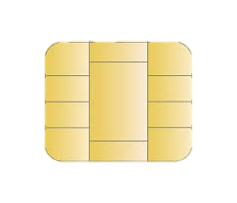

Debit card

For customer service, call +123.456.789

123

DEBIT CARD

CARDHOLDER NAME

XXXX XXXX XXXX XXXX

BANK NAME